**How to Add eSignature on Outlook**

Sample

1. Replace your name**(1),** position**(2)**, phone number**(3)**, and email address**(4)** as in the image sample above.
2. Now let’s go to Outlook application on your computer. Go to **File Tab**

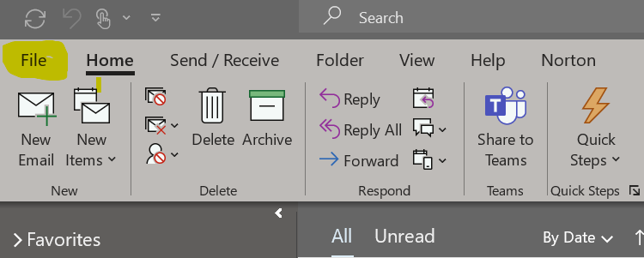

Click on **Options**

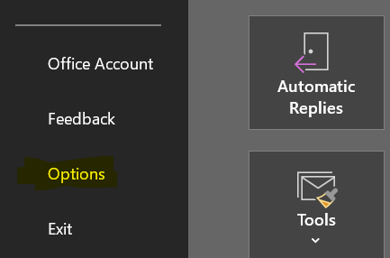

Choose **Mail Tab**

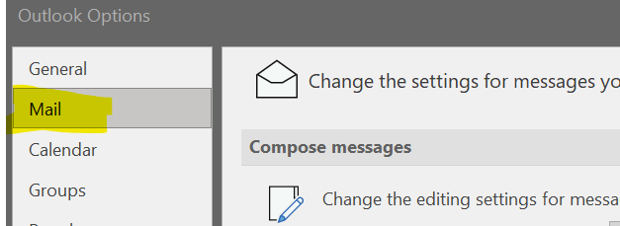

Click on **Signatures…**

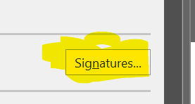

Click on **New** button to create a new signature name if you don’t have one

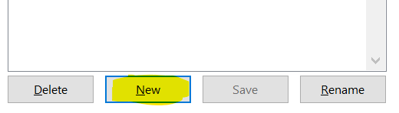

Put your Signature Name into **textbox** then click **OK** button. Ex. **e-Signature**

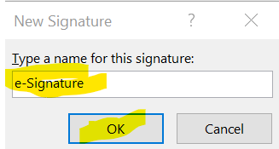

1. Go to your eSignature Official Template then copy it by right click on a box and

choose **Copy. Note**: you have to copy it **three times** to paste it into **Outlook**.

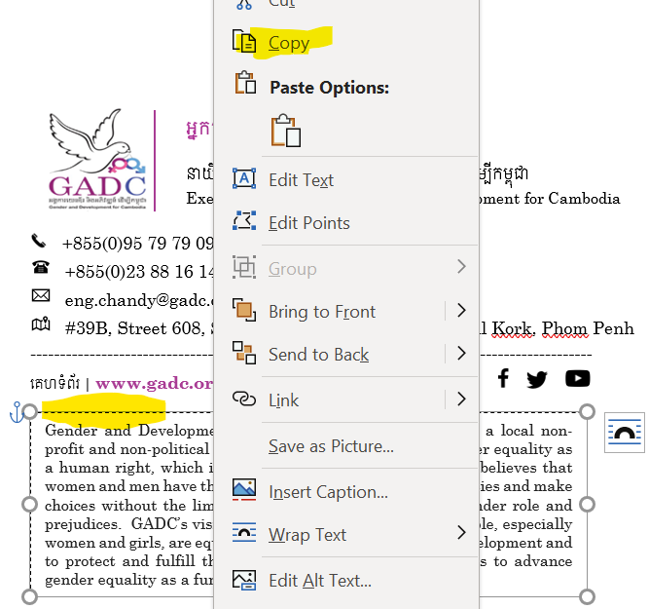

1. 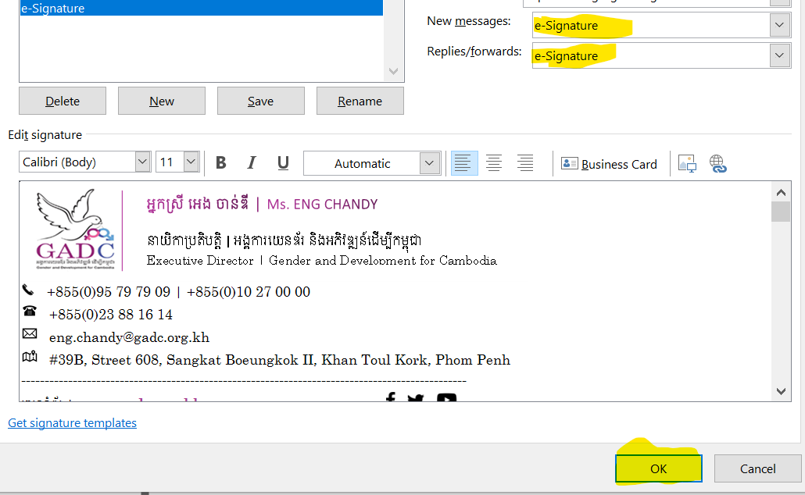Go to **Outlook** again and paste the copied box (do it three times too) into the blank box there. Then you will see it all done and don’t forget to choose the **e-Signature Name** in **New messages** & **Replies/forwards** buttons and then click **OK** button**.**
2. **Done**, try it by clicking on **New Email** button. You will see it all there as in the image below.

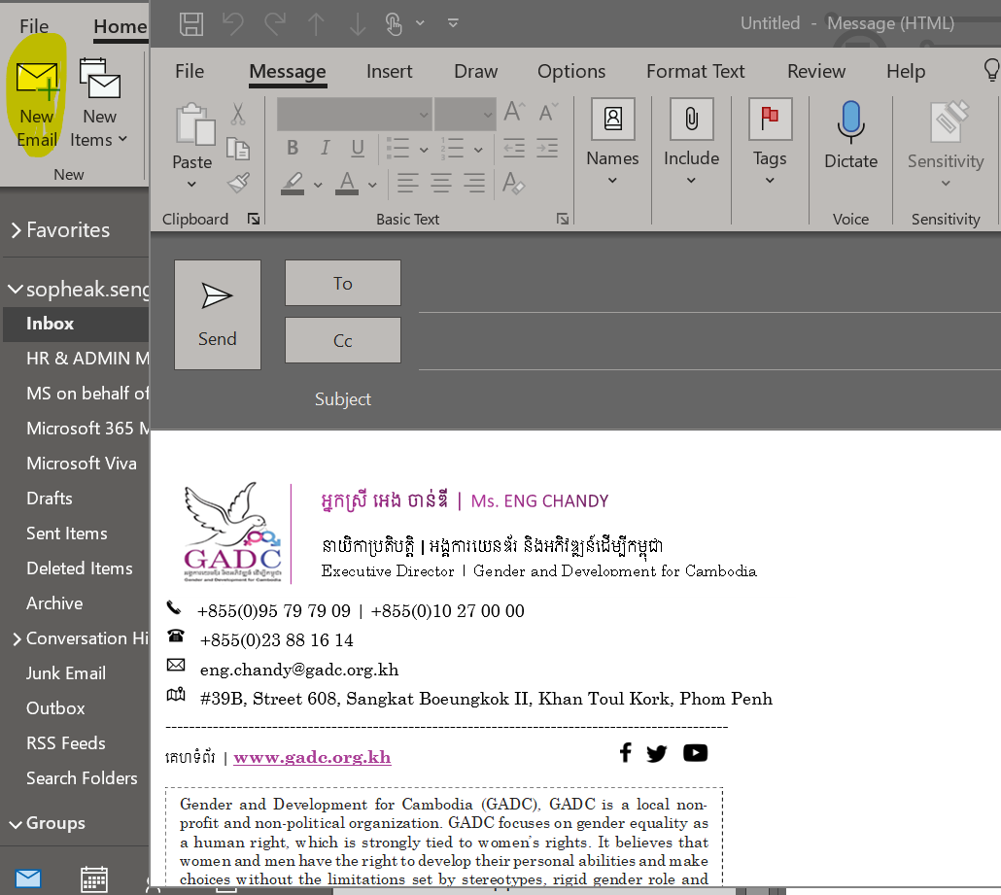

Thanks